STUDENT GRADE MANAGEMENT SYSTEM

1. Define a function calculate_average(marks) that:
Accepts a list of 5 numeric marks (between 0 and 100).
- Returns the average of these marks.

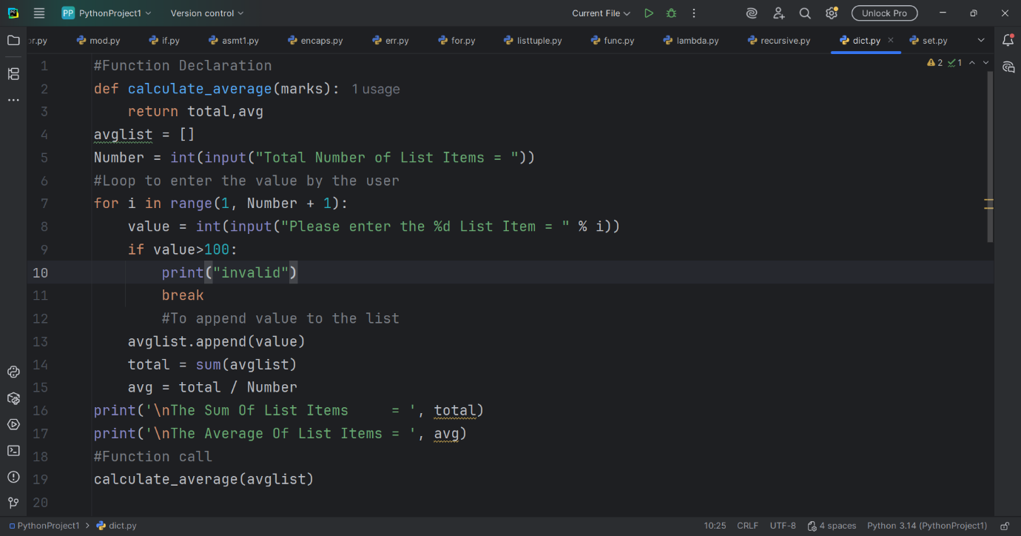

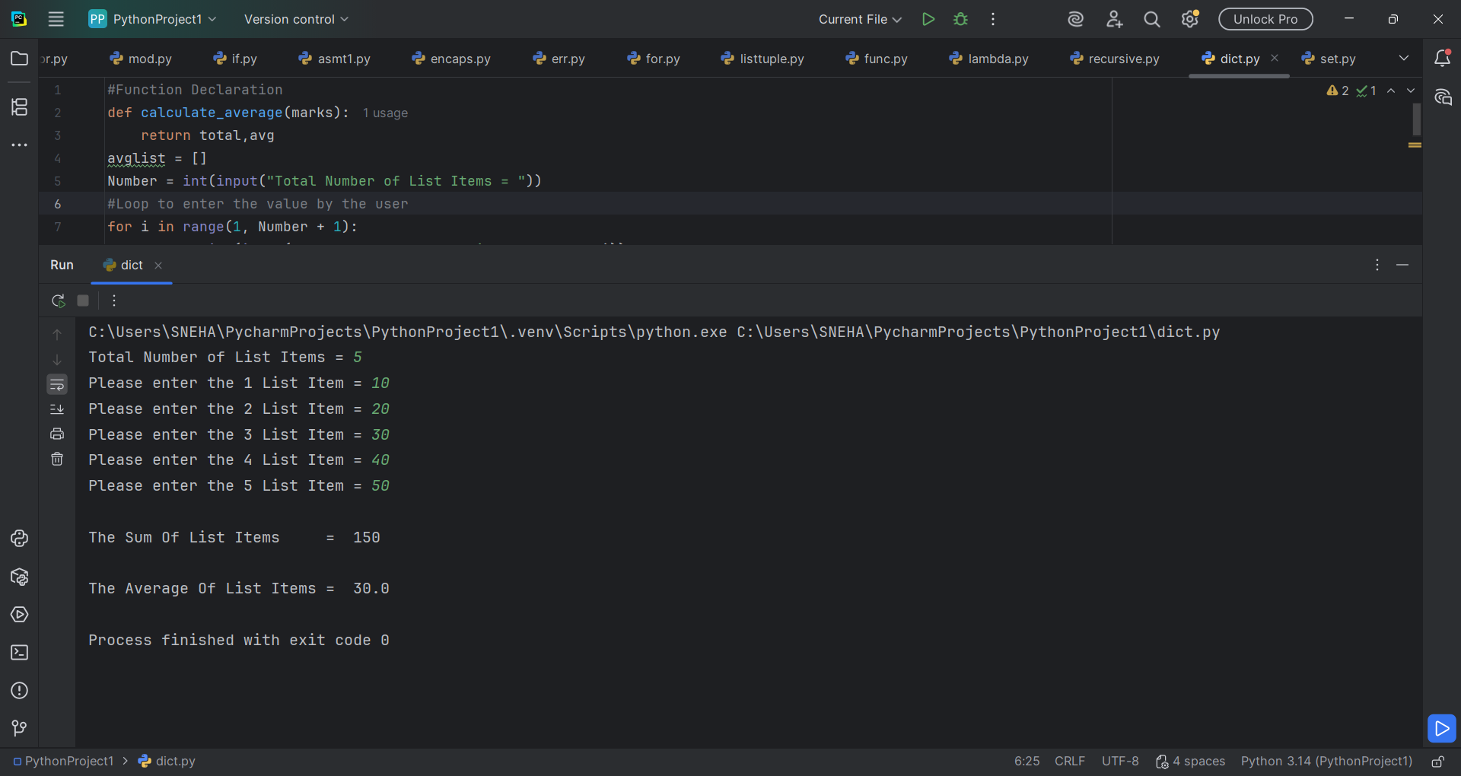

2. Define another function get_grade(average) that:
- Accepts the average mark as input.
- Returns the grade based on the criteria
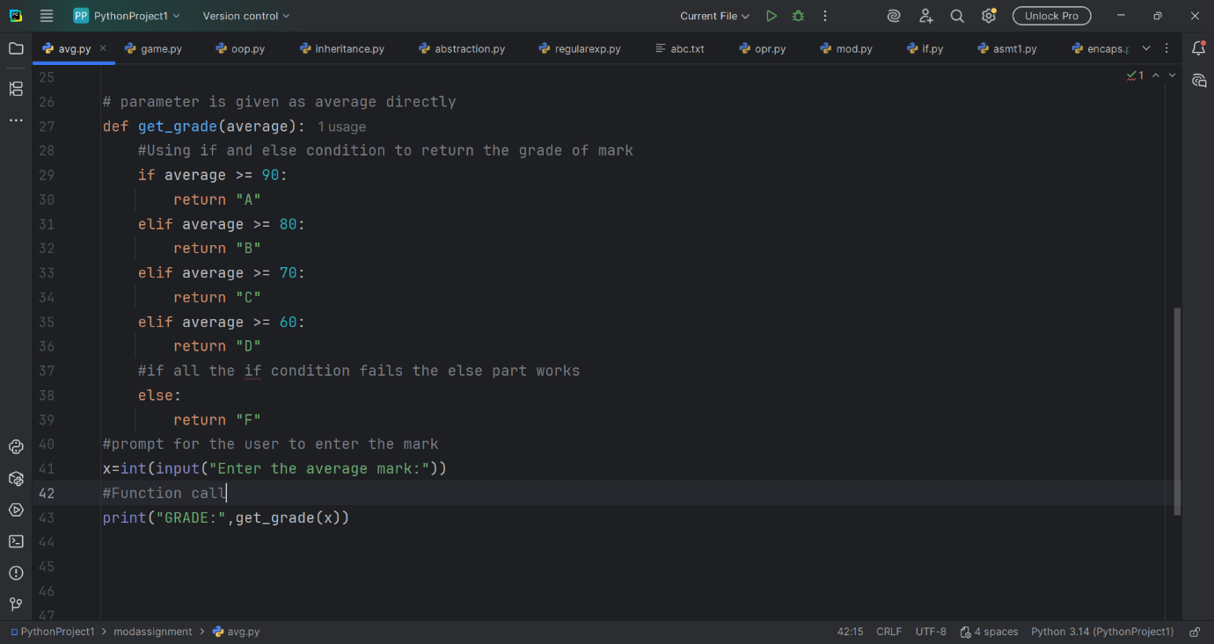

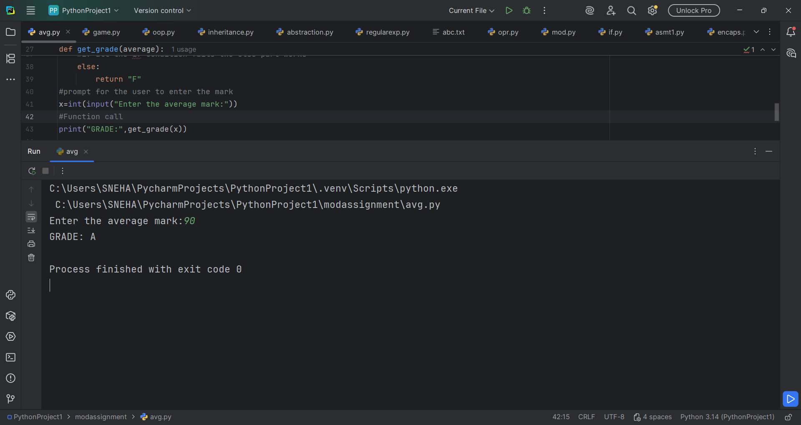

3. In the main program:
- Prompt the user to enter marks for 5 subjects.
- Validate that each mark is a number between 0 and 100.
- Use the defined functions to calculate the average and determine the grade.
- Display both the average and the final grade.

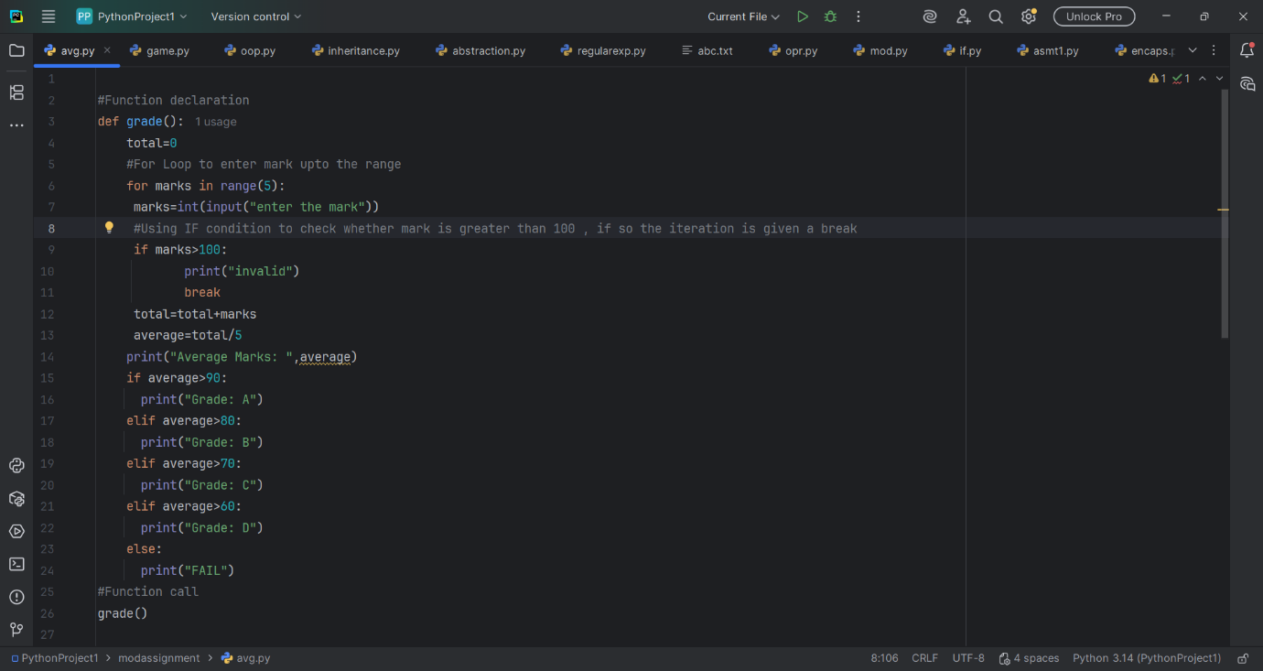

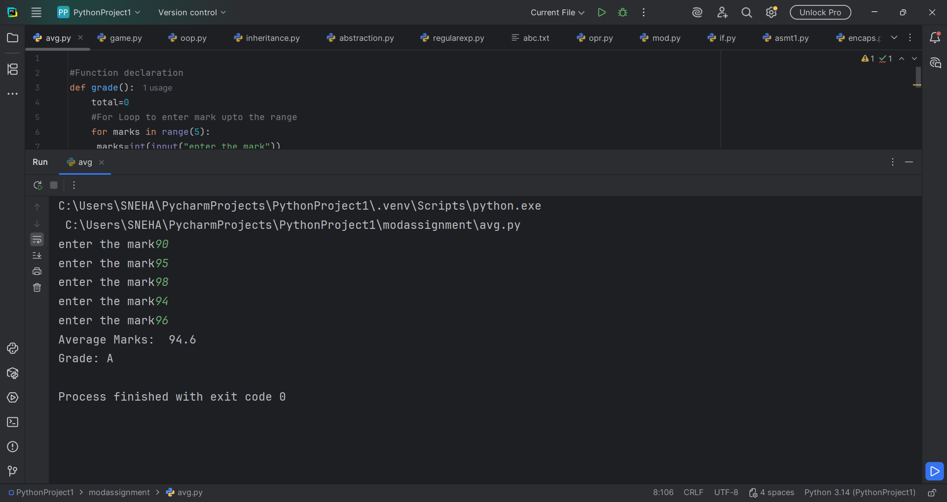

SUMMARY
- OVERVIEW OF PROGRAM 1

- A function is been declared using a function name.
- Numerical numbers is accepted in LIST. In Python LIST is can contain elements of different datatype. It is used to store a collection of items in a single variable.
- The prompt for the user to enter the marks 5 times FOR LOOP is been used. FOR LOOP is used for iteration within the given range.
- IF condition is given in the program to show an INVALID statement if the user is trying to enter the mark beyond 100. IF is used to check any condition , if the condition fails the else part would work.
- The total and average of the marks is been calculated and result is given inside the print statement to print, and finally the function is been called using the function name.

- OVERVIEW OF PROGRAM 2

- Here , a function is created by the function name get_grade(average)
- IF, ELIF and ELSE Condition is been used to return the result of which grade the average belong to .
- IF is the condition to check , if the IF condition fails then the code inside the ELSE part works .
- The ELIF condition is given inside IF and ELSE to give the intermediate code , thus the code check all the condition in IF and ELIF, if all these condition fails, then the ELSE condition works.
- A prompt is been used for the user to enter the average and finally the FUNCTION CALL is made.

- OVERVIEW OF PROGRAM 3

- Prompt is given for the user to enter the marks(int(input()).
- To validate whether the mark is below 100 is not IF condition is been used
- User defined function is the function when is defined by the user itself and the function can be used by the user whenever needed just by using the function name
- And finally the total and the average is printed based on the statement given inside the IF condition and the result is printed.

